Troubleshooting (SKIPPING) replication errors like 20598 and others
Open replication monitor and double click on the publication you are troubleshooting
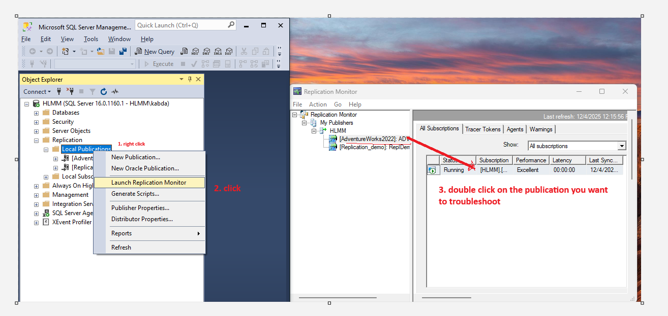

After double-clicking this pops up
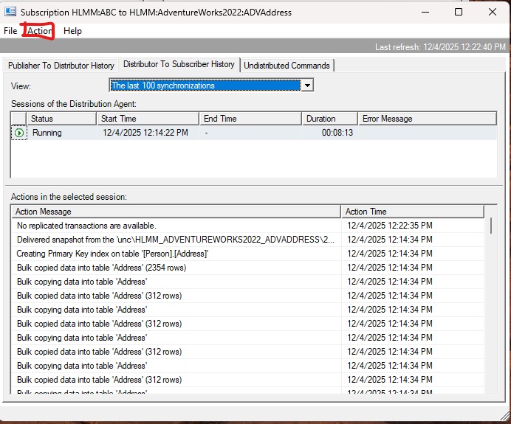
Click Agent profile. Agent profile will let you continue replication with the consistency errors like 20598 (row not found), 515 (not null) , 2627 (PK, default). If you have rows in both publisher and subscriber but 20598 is reported you can skip it by choosing “continue on data consistency error”. If you want to have a custom profile with custom error codes, you can add “new”
Default - no skipping errors

Continue on data consistency errors: replication continues despite errors like 20598, 2627. This default error codes cant be changed under this profile.

Add new to customize error code. Choose continue on data consistency errors because the default will not let you edit the errors

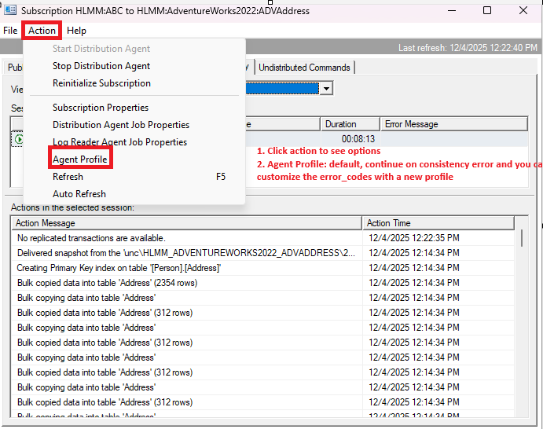

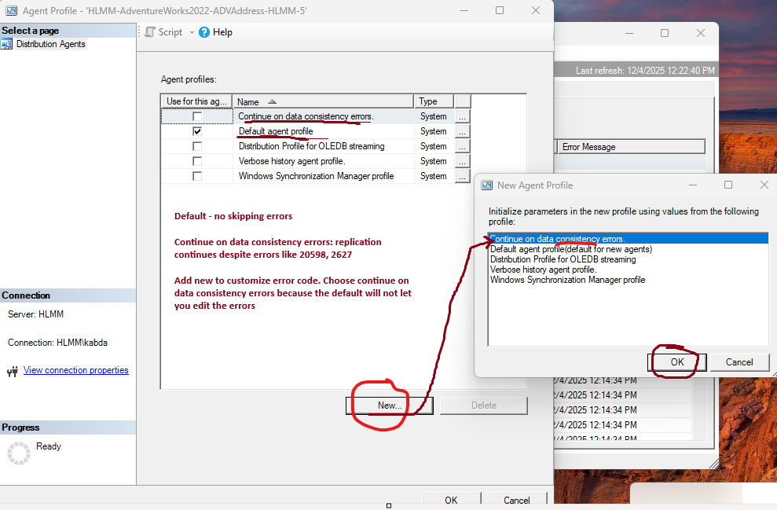

Once you choose and “OK” either Continue on data consistency errors or added new profile next you have to STOP (first) and (then) Start the distribution agent. When changing the profile from default, it will show you a new message about the change.
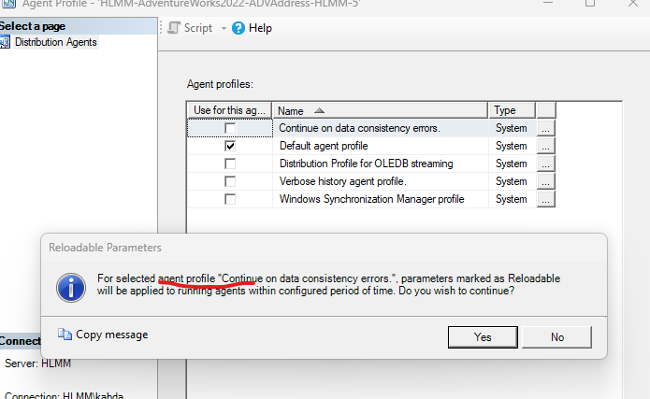

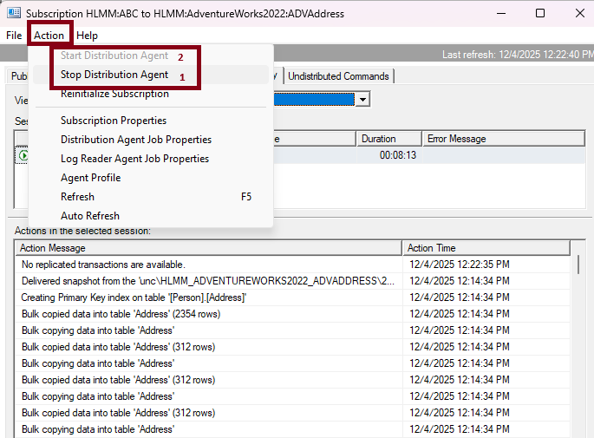

Once you confirm data is synchronized and no latency, then revert back to DEFAUTL and do “STOP” then “Start” similar to above.

